The main differences between `std::vector` and `std::list` in C++ lie in their underlying data structures, memory allocation, and performance characteristics for various operations. Here’s a comparison:

### 1. **Underlying Data Structure**

- **Vector**: Implemented as a dynamic array. Elements are stored in contiguous memory locations.

- **List**: Implemented as a doubly-linked list. Elements are stored in non-contiguous memory locations, with each element having pointers to the next and previous elements.

### 2. **Memory Allocation and Access**

- **Vector**: Memory is allocated as a single contiguous block. Accessing elements by index is fast and has constant time complexity \(O(1)\) due to direct access using the index.

- **List**: Memory is allocated for each element separately. Access by index is slow \(O(n)\) because you must traverse the list from the beginning to reach a specific index.

### 3. **Insertion and Deletion Performance**

- **Vector**:

- Inserting or deleting elements at the end is efficient \(O(1)\), but inserting or deleting in the middle or at the beginning is slow \(O(n)\) due to the need to shift elements to maintain contiguity.

- When the vector’s capacity is exceeded, it must reallocate and copy all elements to a new, larger memory block, which can be costly.

- **List**: Insertion and deletion at any position (beginning, middle, end) are efficient \(O(1)\) because you only need to update pointers, without any need for shifting elements.

### 4. **Use Cases**

- **Vector**: Preferred when you need fast random access and mostly append operations. Suitable for scenarios where data size changes infrequently or where elements are often accessed by index.

- **List**: Preferred when frequent insertions and deletions are needed, especially in the middle of the sequence. Suitable for scenarios where sequential access is required, rather than random access.

### 5. **Memory Overhead**

- **Vector**: Generally has less memory overhead since it only requires additional space for potential resizing (extra capacity).

- **List**: Has higher memory overhead because each element requires extra memory for the pointers to the next and previous elements.

### 6. **Additional Features**

- **Vector**: Supports features like `reserve` to pre-allocate memory, which can help avoid reallocations if the final size is known in advance.

- **List**: Does not support `reserve` or `shrink_to_fit` since it does not have a contiguous block of memory. However, it provides `splice`, a function to move elements between lists efficiently.

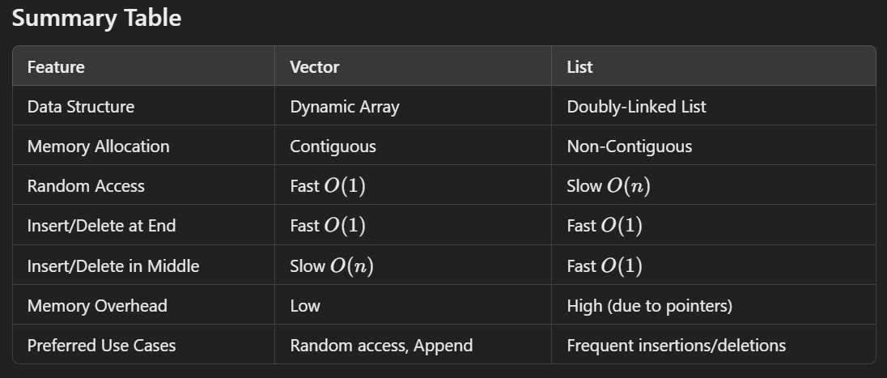

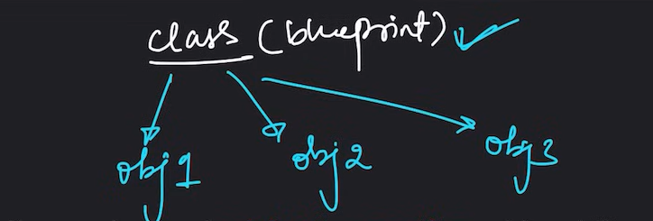

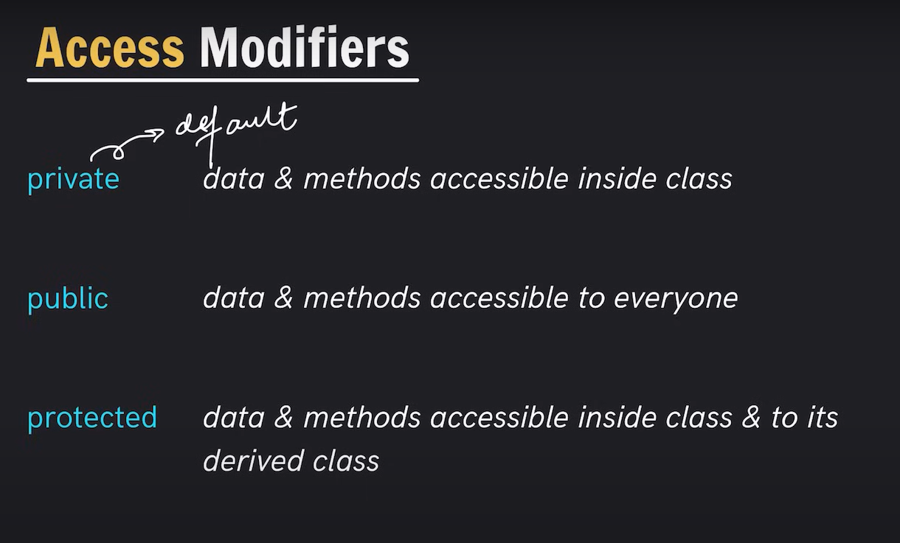

**OOPS**

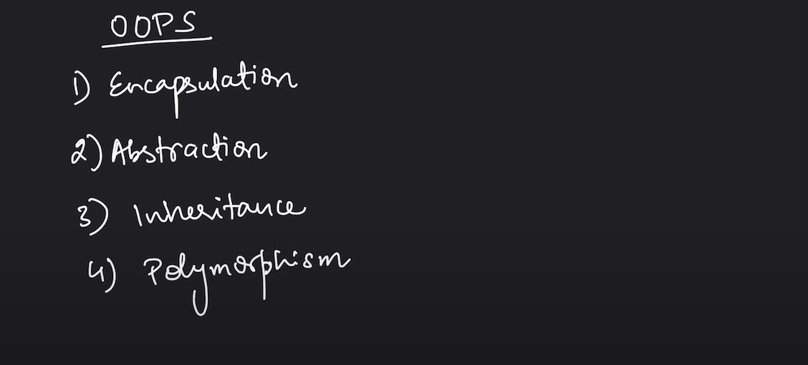

Encapsulation

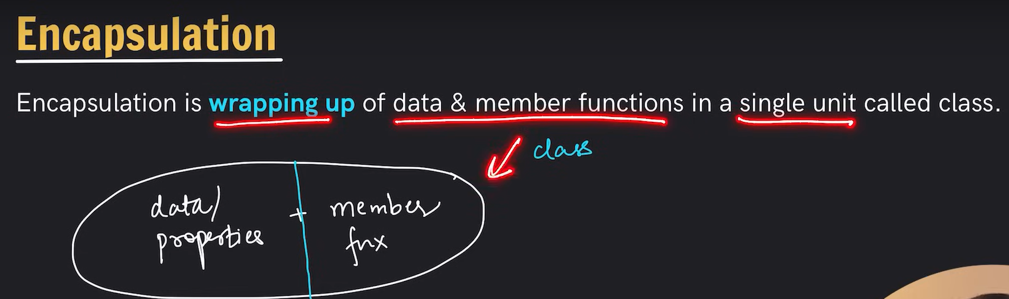

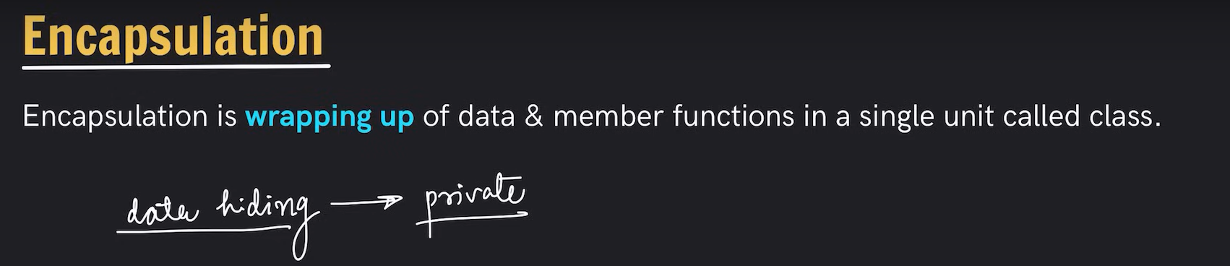

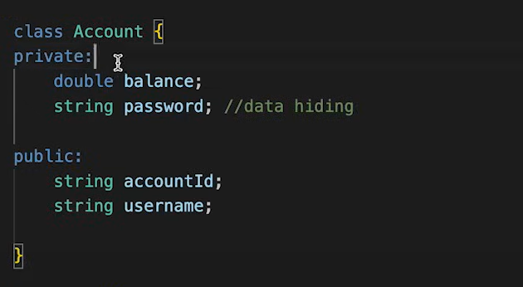

Constructor

Special method invoked automatically at time of object creation. Used for Initialisation.

· Same name as class

· Constructor doesn't have a return type

. Only called once (automatically), at object creation

. Memory allocation happens when constructor is called

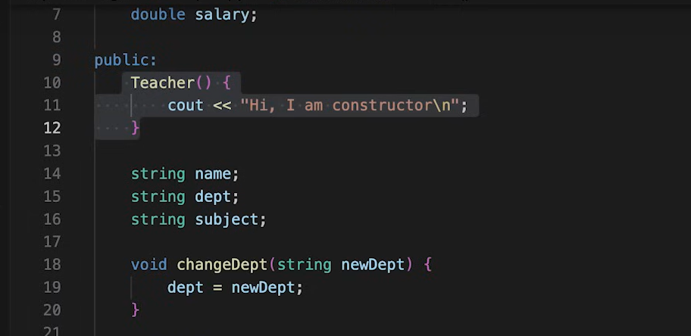

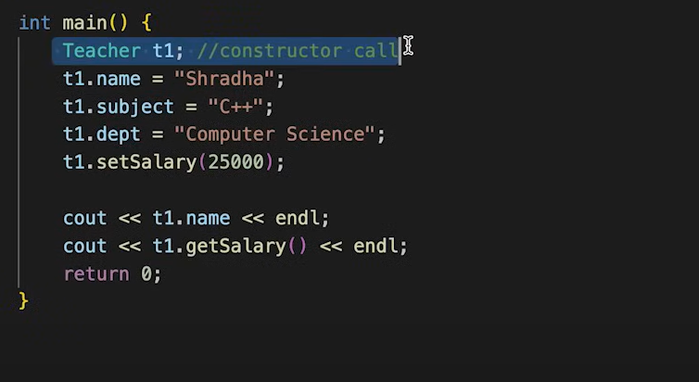

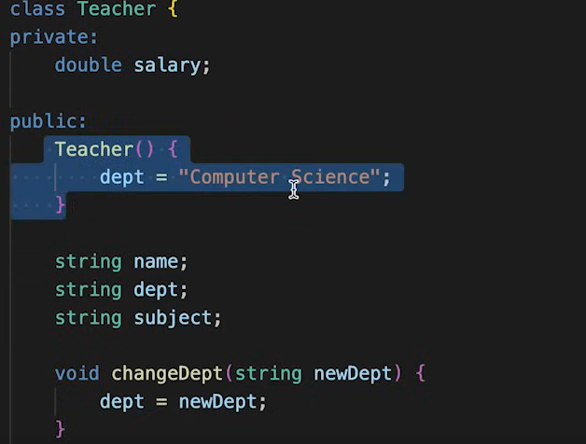

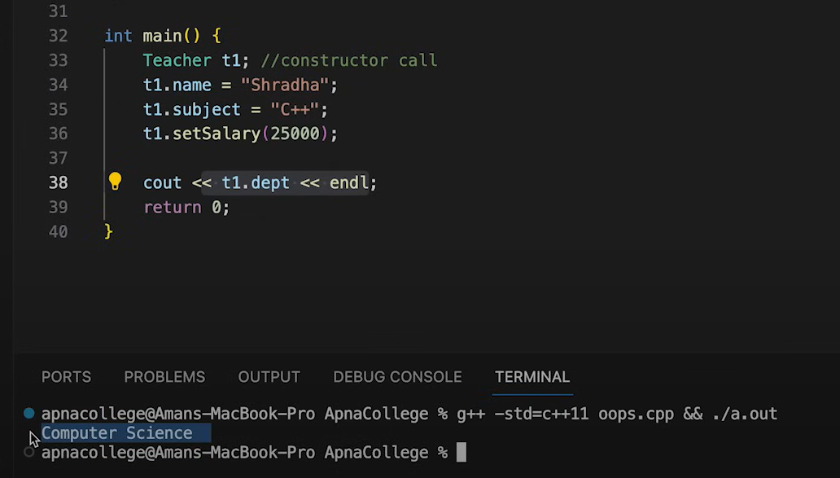

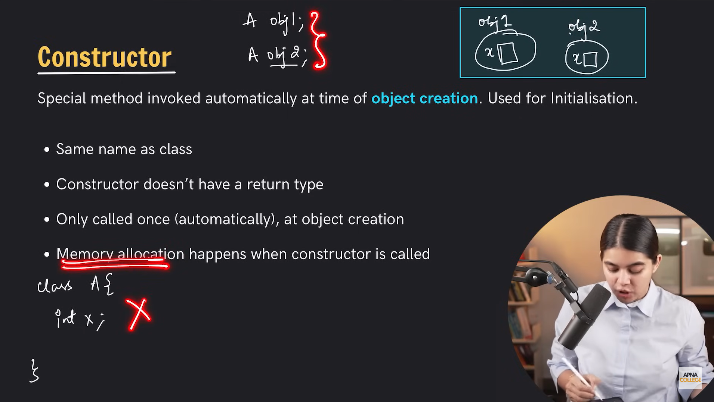



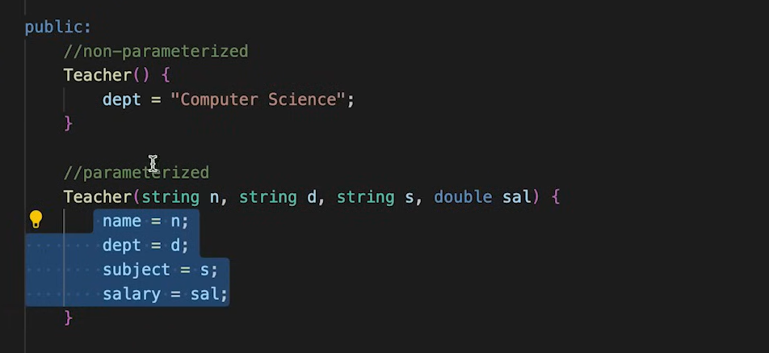



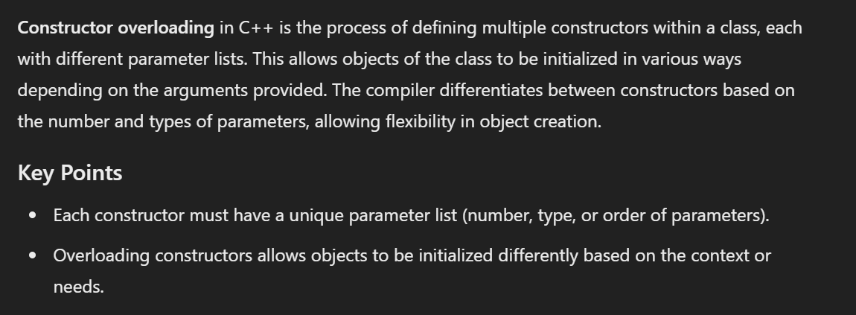

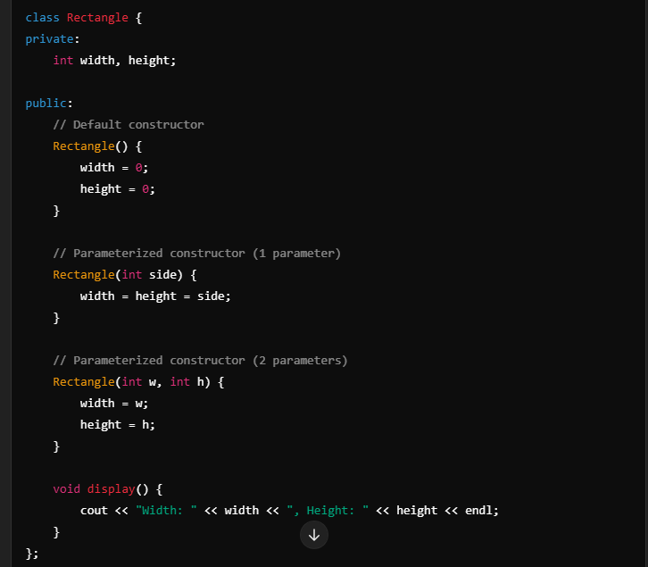

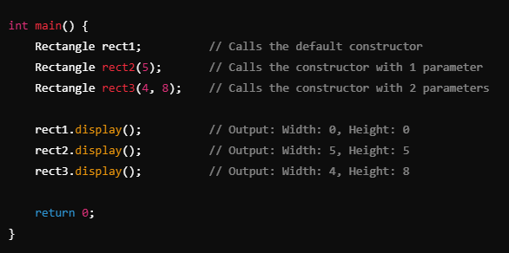

this in constructor

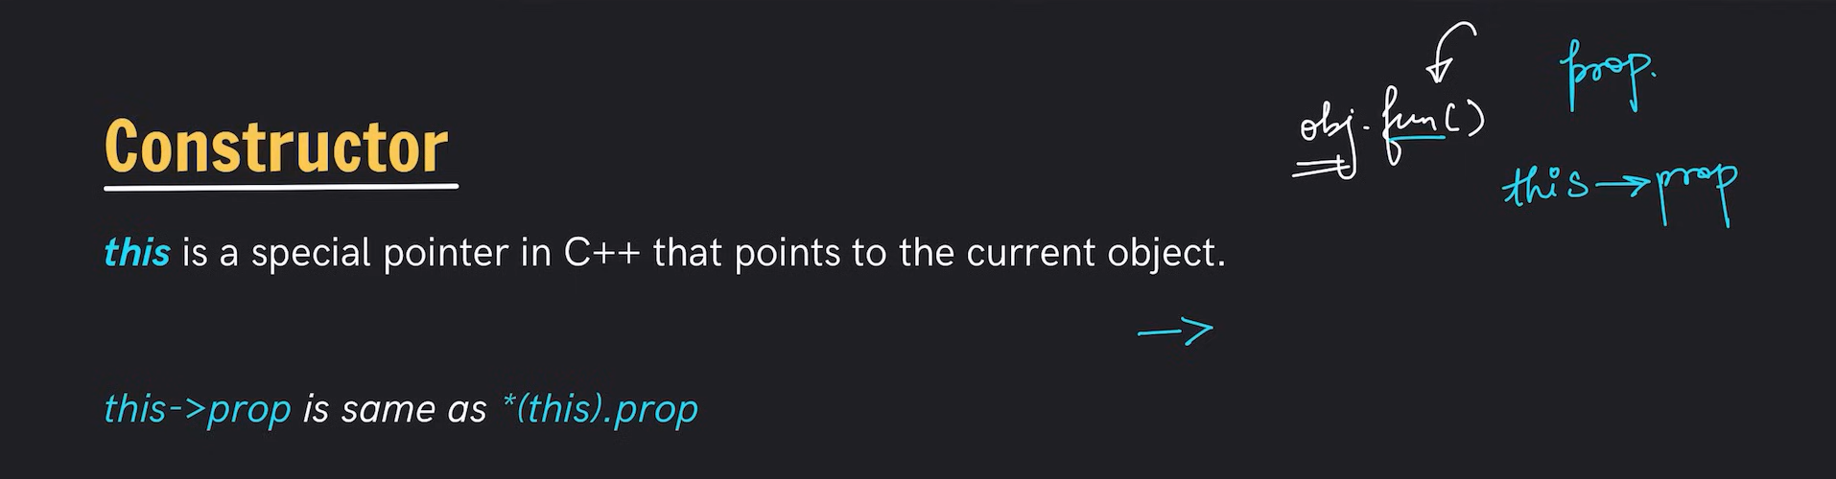

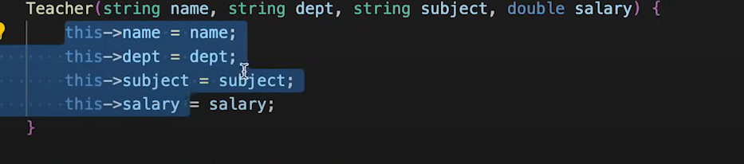

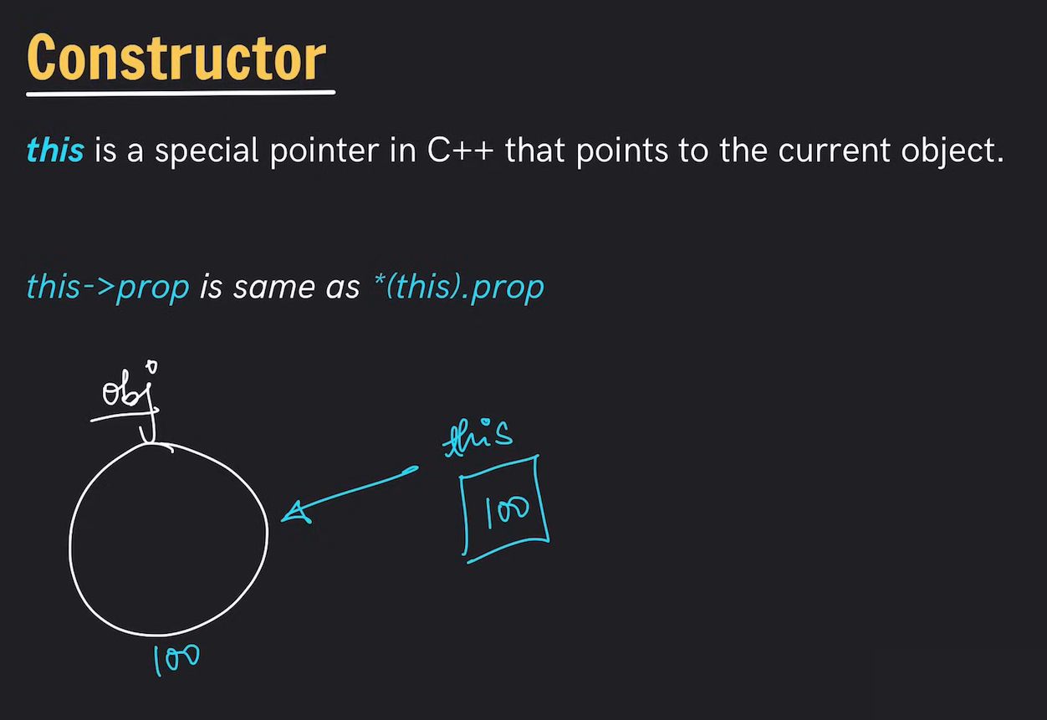

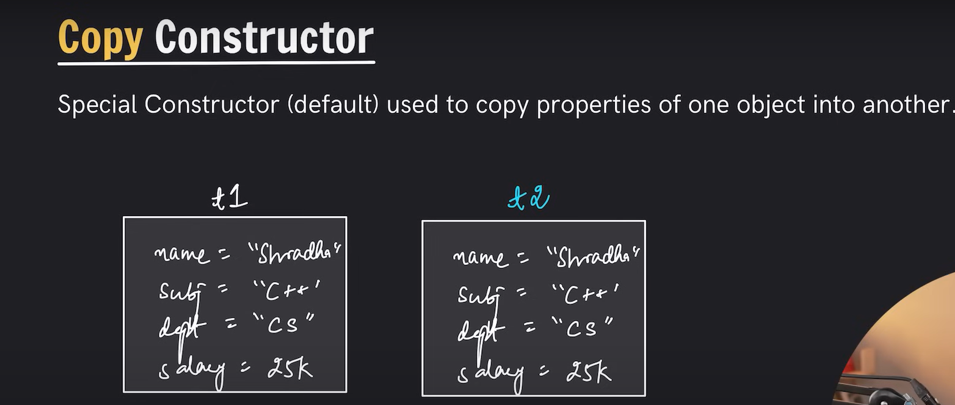

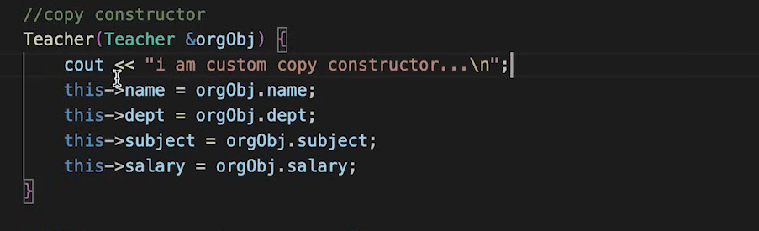

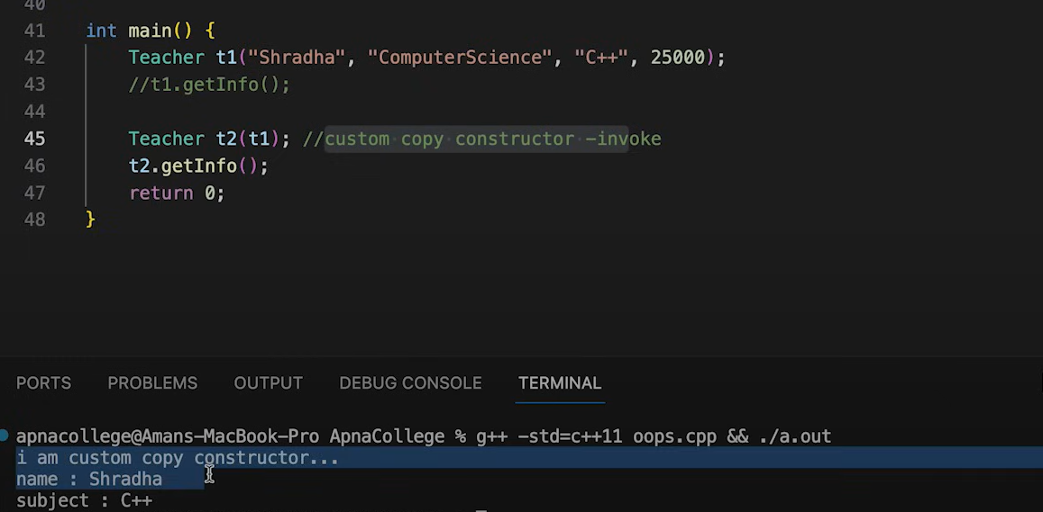

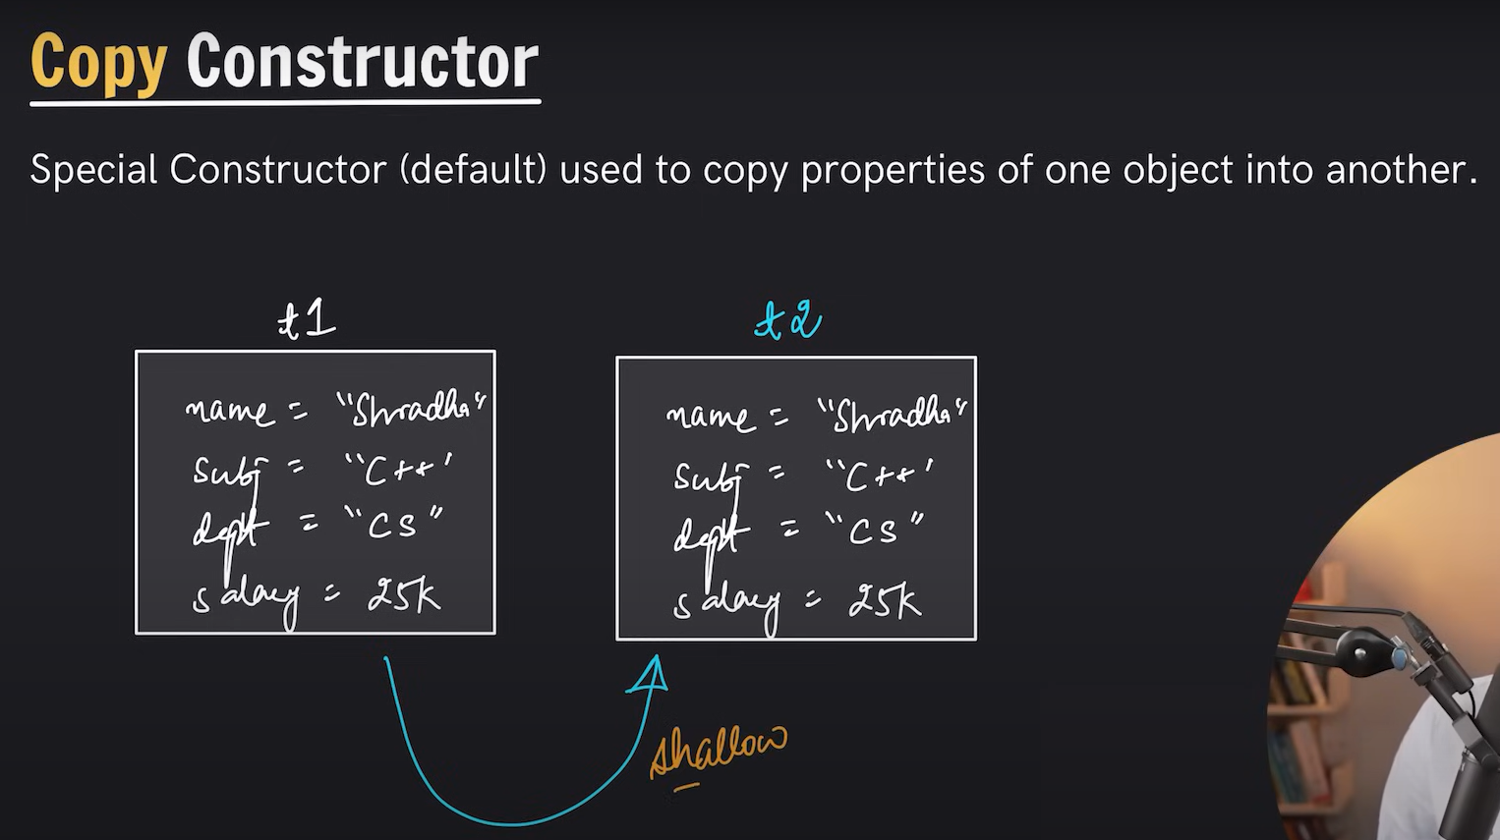

In C++, **shallow copy** and **deep copy** refer to two different ways of copying data members of an object when implementing copy constructors or assignment operators. The choice between the two depends on how the class handles dynamically allocated memory or shared resources.

**Shallow Copy**

* **Definition**: A shallow copy copies the values of the data members as they are, including pointers or references. The new object shares the same memory as the original object for any dynamically allocated resources.

**Characteristics:**

1. **Pointer Copy**: Only the memory address (not the data it points to) is copied.
2. **Shared Resource**: Both the original and the copied objects point to the same memory.
3. **Default Behavior**: The default copy constructor and assignment operator provided by the compiler perform a shallow copy.
4. **Risk**: If the original object releases the memory, the copied object might end up with a dangling pointer, leading to undefined behavior.

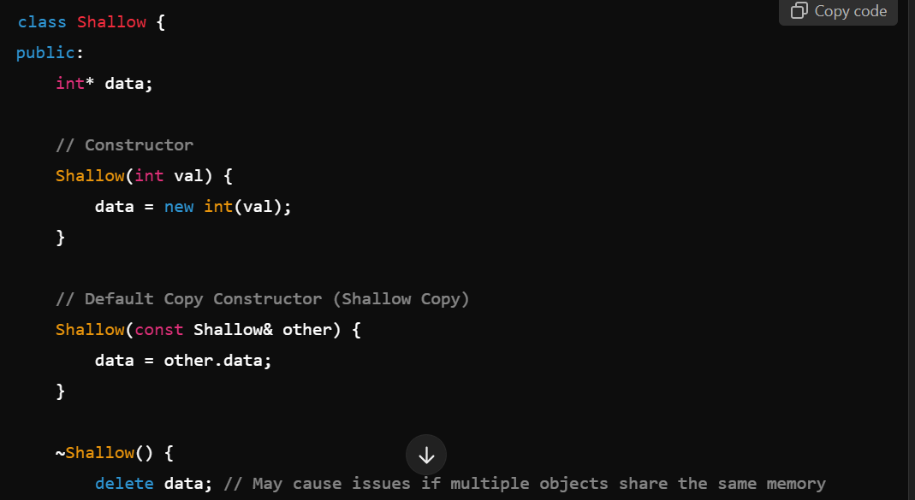

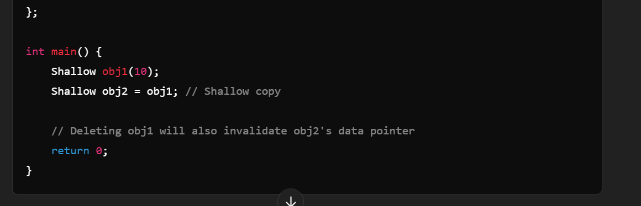

**Deep Copy**

* **Definition**: A deep copy duplicates the actual data members and dynamically allocates separate memory for the new object, ensuring the copied object owns its resources independently.

**Characteristics:**

1. **Full Resource Duplication**: The copy constructor allocates new memory and copies the data explicitly.
2. **Independent Objects**: Changes to the copied object do not affect the original.
3. **Custom Implementation**: Requires explicit implementation of the copy constructor and assignment operator.
4. **No Dangling Pointer**: Eliminates risks associated with shared resources.

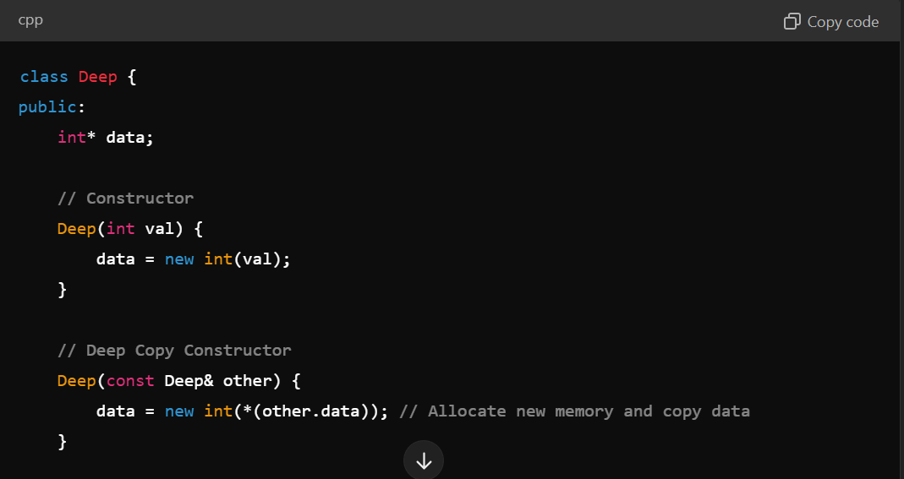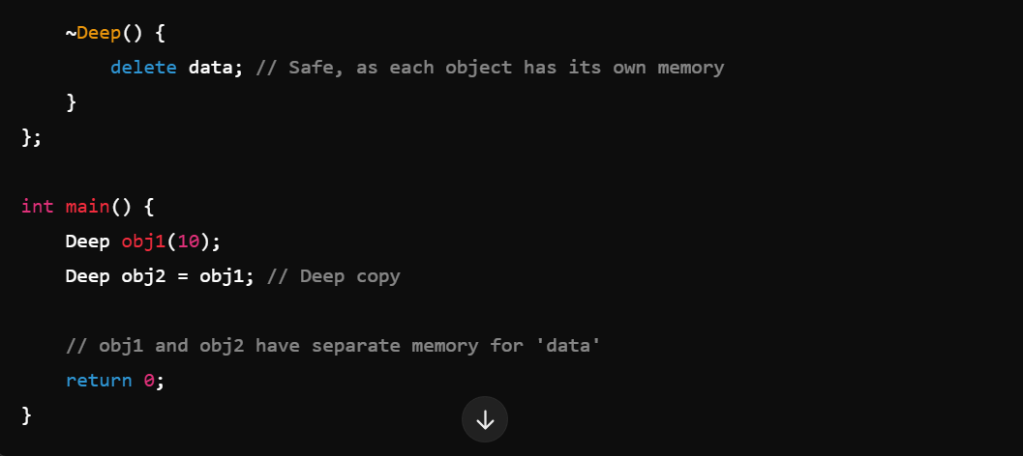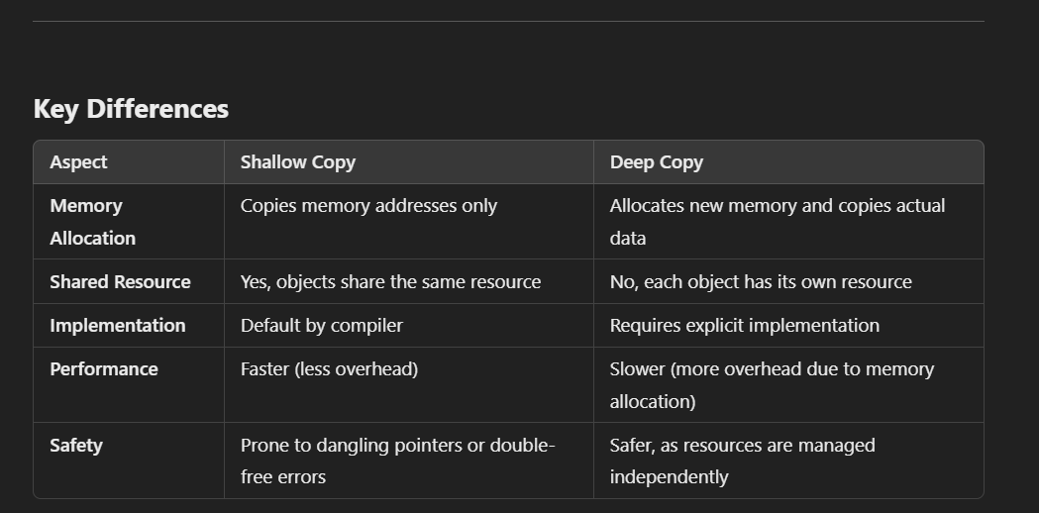

**When to Use**

* **Shallow Copy**: Suitable when the class does not manage dynamic memory or shared resources.
* **Deep Copy**: Required when the class uses dynamic memory, owns resources, or needs resource independence.

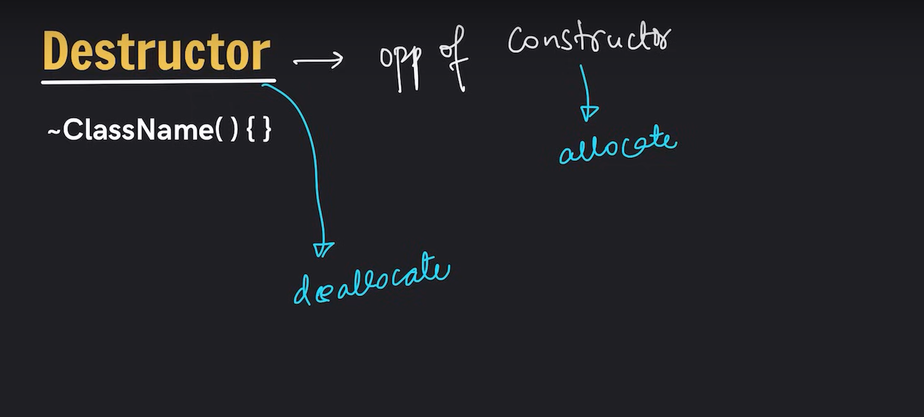

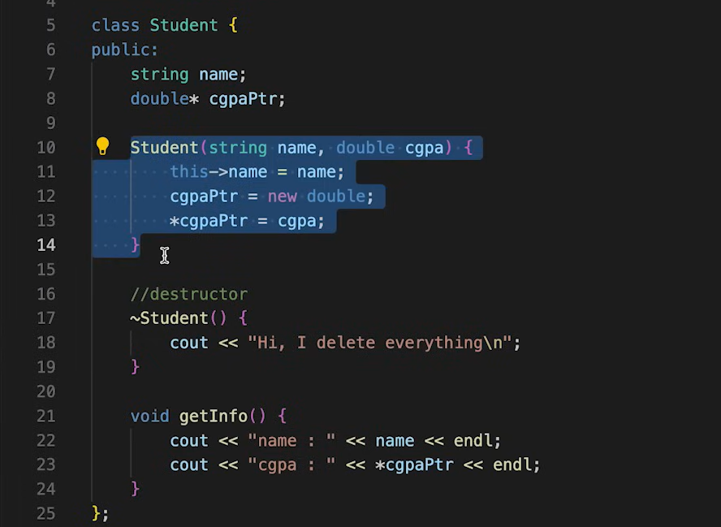

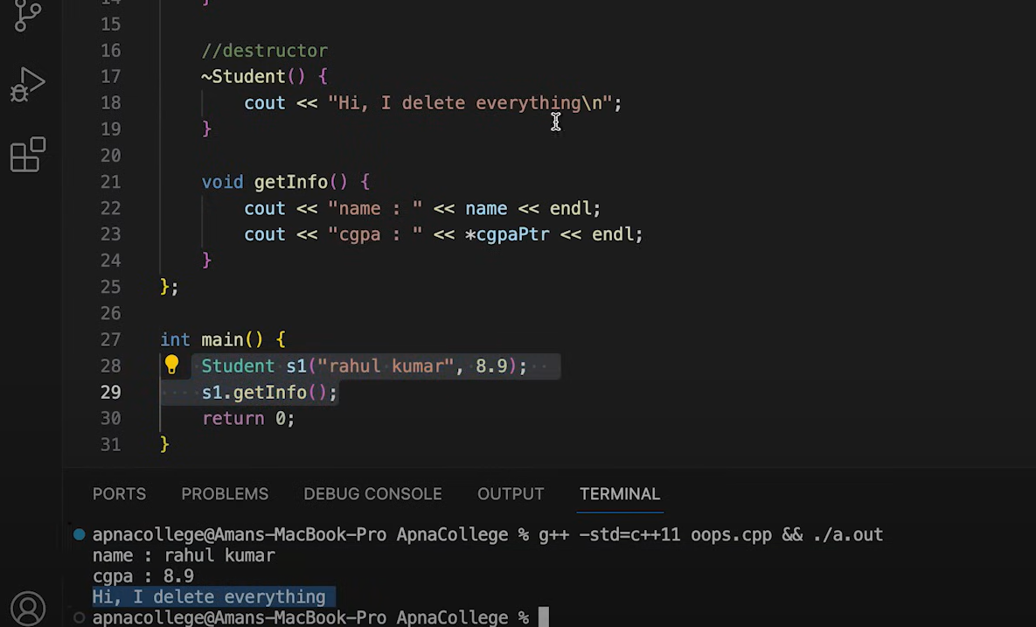

**New keyword**

The new keyword in C++ is used for dynamic memory allocation. It allows you to allocate memory for a variable or an array on the heap during runtime. The memory allocated using new persists until it is explicitly deallocated using the delete or delete[] keyword.

**Syntax:**

1. **For a single object:**
2. Type* pointer = new Type;
3. **For an array of objects:**
4. Type* pointer = new Type[size];

**Example:**

**Allocating memory for a single variable:**

#include <iostream>

using namespace std;

int main() {

int* ptr = new int; // Allocates memory for an integer

*ptr = 42; // Assigns a value to the allocated memory

cout << "Value: " << *ptr << endl; // Outputs: Value: 42

delete ptr; // Deallocates memory

return 0;

}

**Allocating memory for an array:**

#include <iostream>

using namespace std;

int main() {

int* arr = new int[5]; // Allocates memory for an array of 5 integers

for (int i = 0; i < 5; ++i) {

arr[i] = i + 1; // Assigns values to the array

}

for (int i = 0; i < 5; ++i) {

cout << arr[i] << " "; // Outputs: 1 2 3 4 5

}

cout << endl;

delete[] arr; // Deallocates memory for the array

return 0;

}

**Key Points:**

1. Always use delete to free memory allocated with new to avoid memory leaks.
2. Use delete[] for arrays allocated with new[].
3. Memory allocated with new is not automatically initialized (except for new with basic types if explicitly initialized or in specific cases like new int()).

**Alternatives:**

In modern C++, it's recommended to use **smart pointers** (e.g., std::unique_ptr or std::shared_ptr) or **containers** (like std::vector) to manage memory automatically and avoid manual memory management issues.

**Inheritance**

Inheritance in C++ is a fundamental concept of object-oriented programming that allows a class (called a derived or child class) to inherit properties and behaviors (data members and member functions) from another class (called a base or parent class). It promotes code reuse and establishes a relationship between classes.

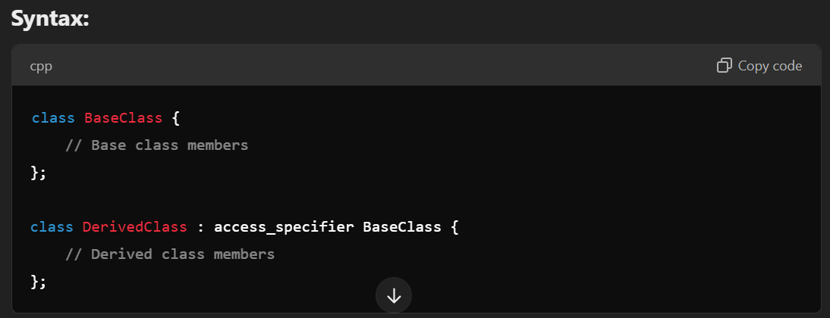

The access_specifier determines how the members of the base class are inherited in the derived class. Common options are public, protected, and private. 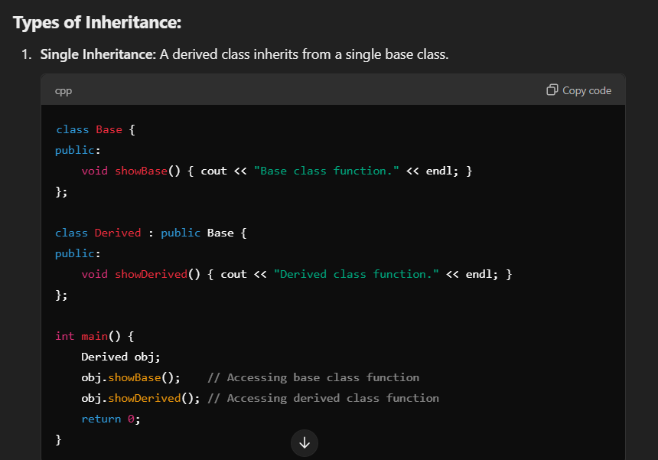

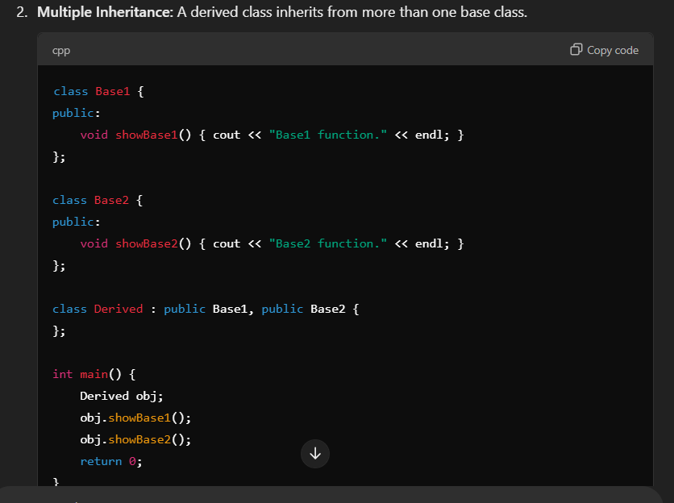

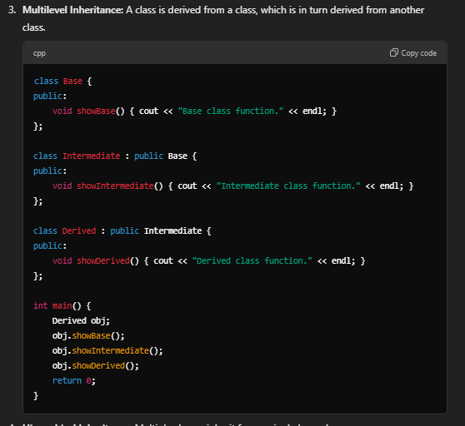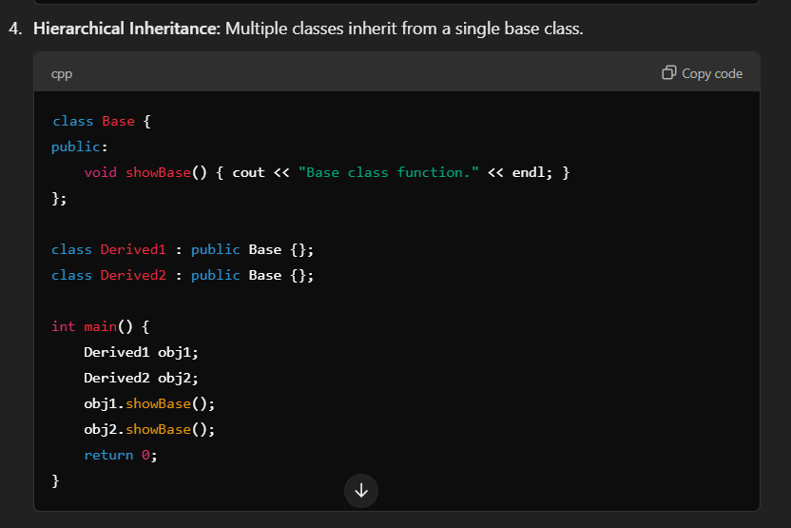

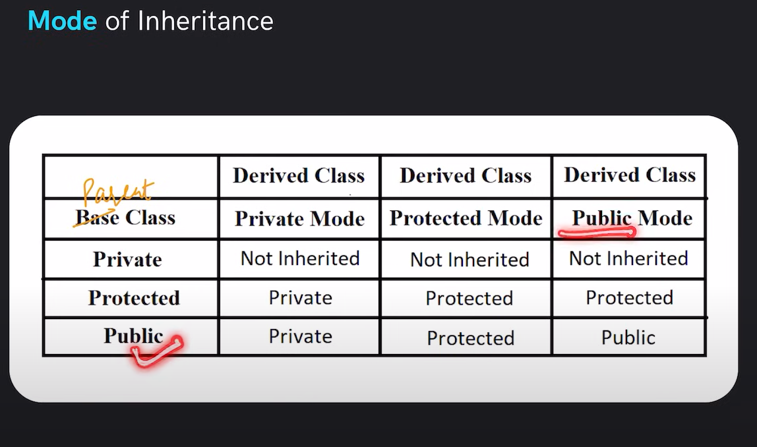

**Polymorphism**

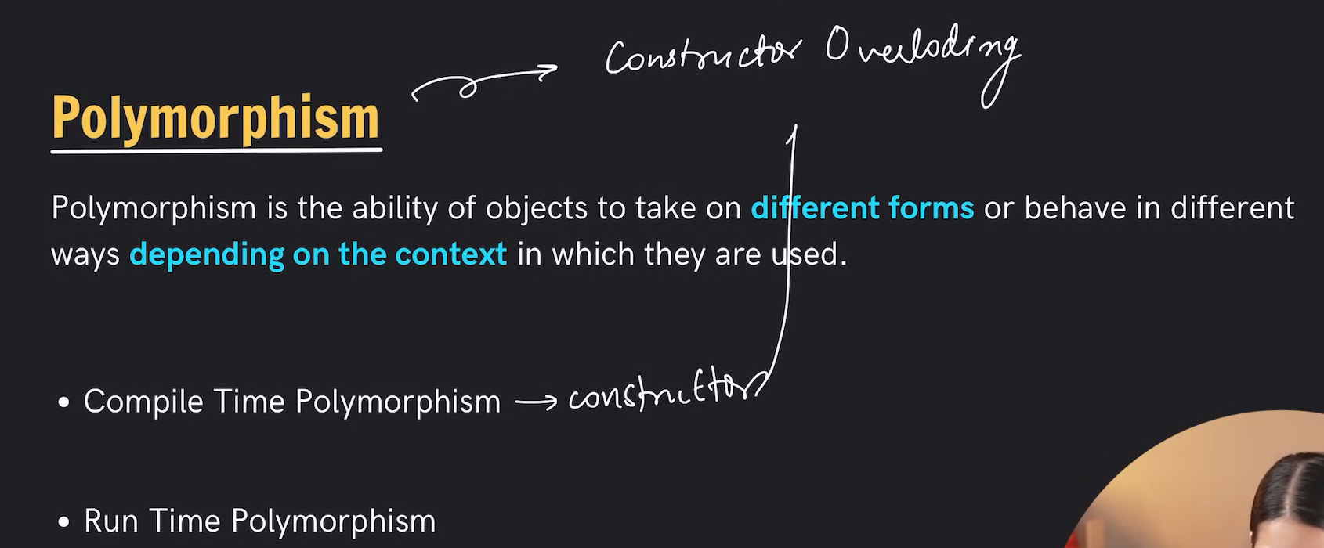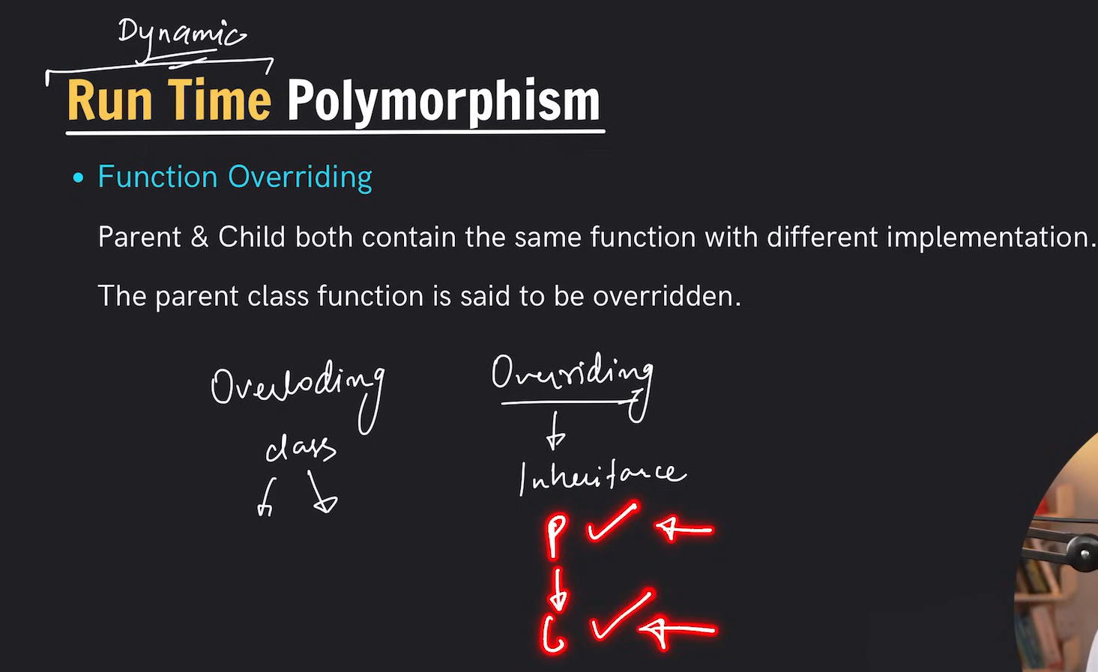

Polymorphism in C++ is a core concept of object-oriented programming that allows a function, operator, or object to behave differently in different contexts. The term "polymorphism" means "many forms." In C++, polymorphism is achieved through **function overloading, operator overloading, and inheritance with virtual functions.**

**Types of Polymorphism in C++:**

1. **Compile-Time Polymorphism (Static Binding or Early Binding):**
   * The method call is resolved at compile time.
   * Achieved using **function overloading** and **operator overloading**.
2. **Run-Time Polymorphism (Dynamic Binding or Late Binding):**
   * The method call is resolved at runtime.
   * Achieved using **virtual functions** and **inheritance**.

**1. Compile-Time Polymorphism:**

**Function Overloading:**

This allows multiple functions with the same name but different parameter types or counts.

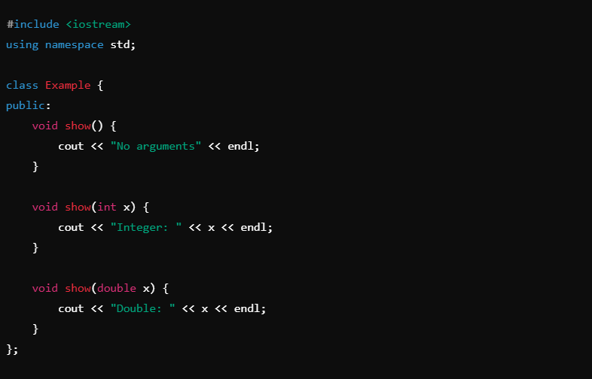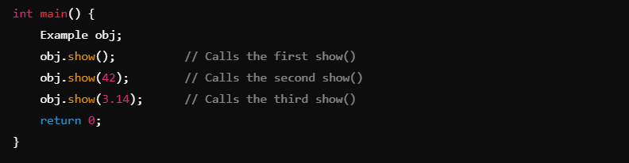

**Operator Overloading:**

This allows redefining how operators work for user-defined types.

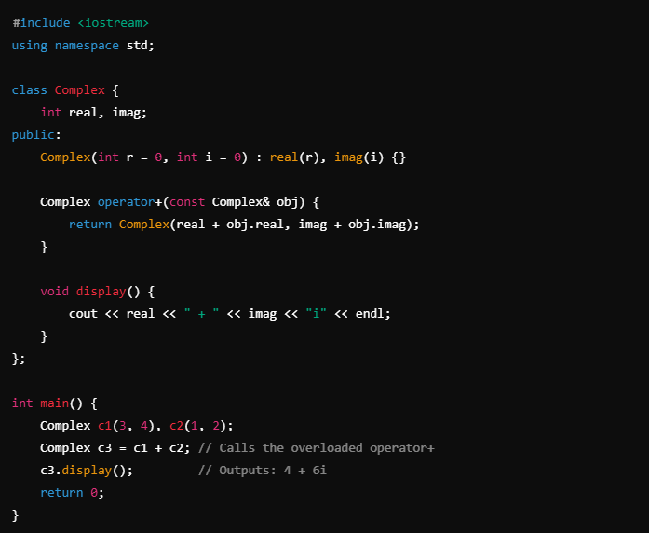

**2. Run-Time Polymorphism:**

**Virtual Functions:**

Virtual functions allow a derived class to override a base class method. The method to execute is determined at runtime based on the object's actual type.

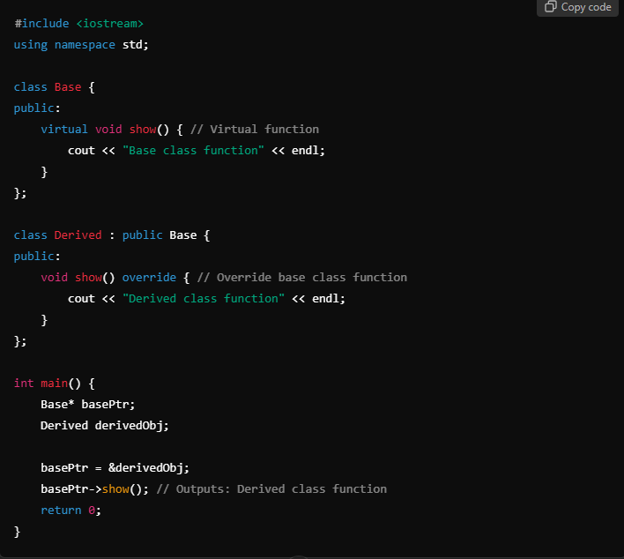**Key Points about Virtual Functions:**

1. Declared using the virtual keyword in the base class.
2. A base class pointer or reference can invoke the derived class's overridden method.
3. Helps achieve **dynamic binding**.
4. If a base class function is not virtual, the base class version is invoked, regardless of the object type.

**Pure Virtual Functions and Abstract Classes:**

A **pure virtual function** is a virtual function with no definition in the base class. It forces derived classes to provide their implementation, making the base class an **abstract class**.

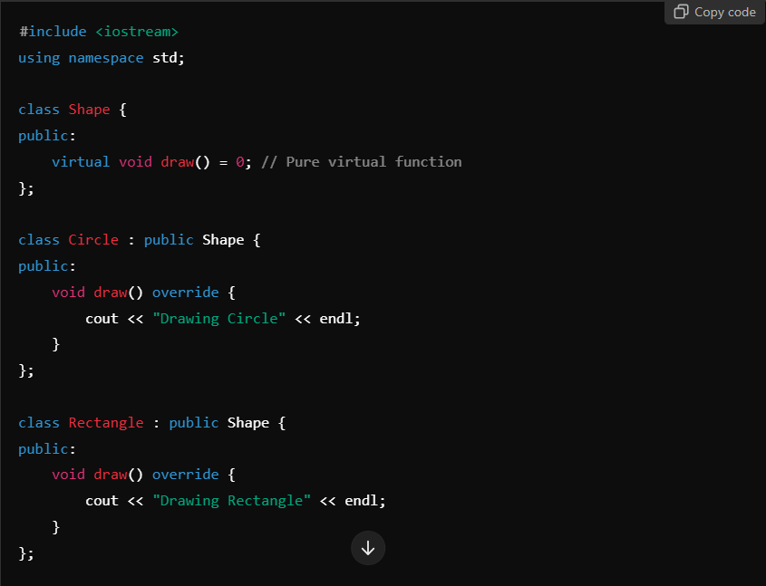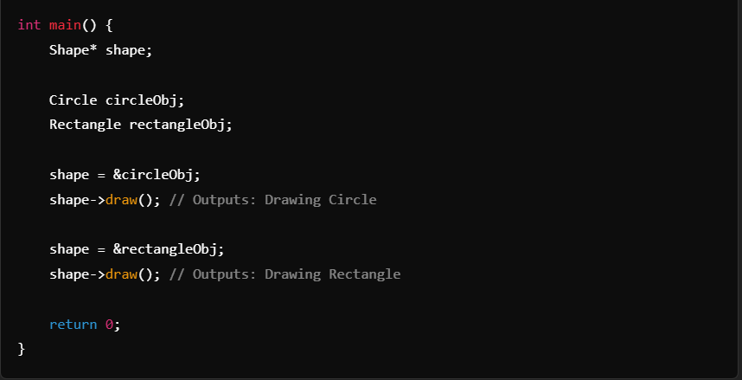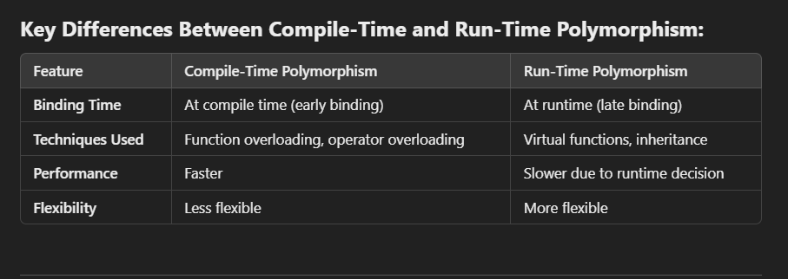**Advantages of Polymorphism:**

1. Promotes code reusability and flexibility.
2. Enables the design of systems that are scalable and easy to maintain.
3. Supports runtime decision-making for behavior implementation.

Polymorphism is one of the pillars of object-oriented programming, enabling extensible and dynamic designs.

**Abstraction**

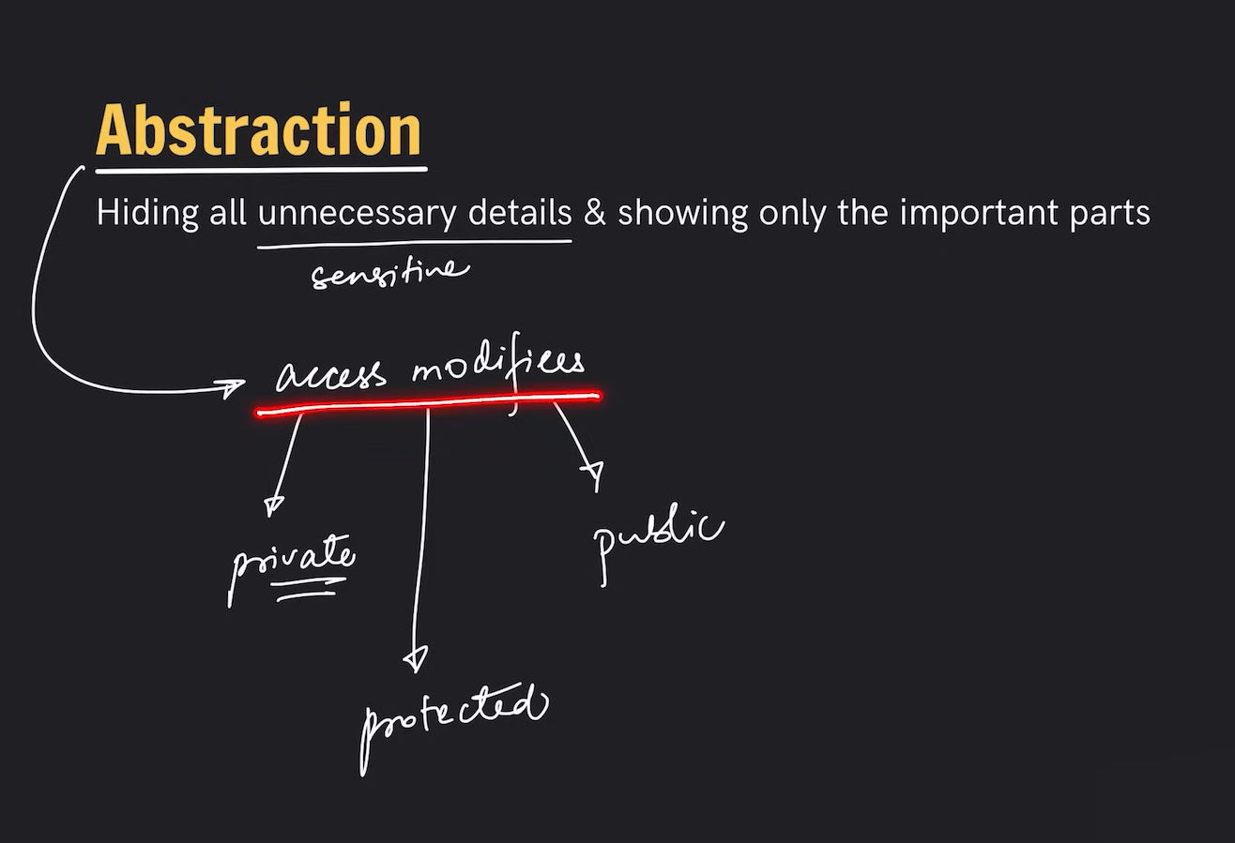

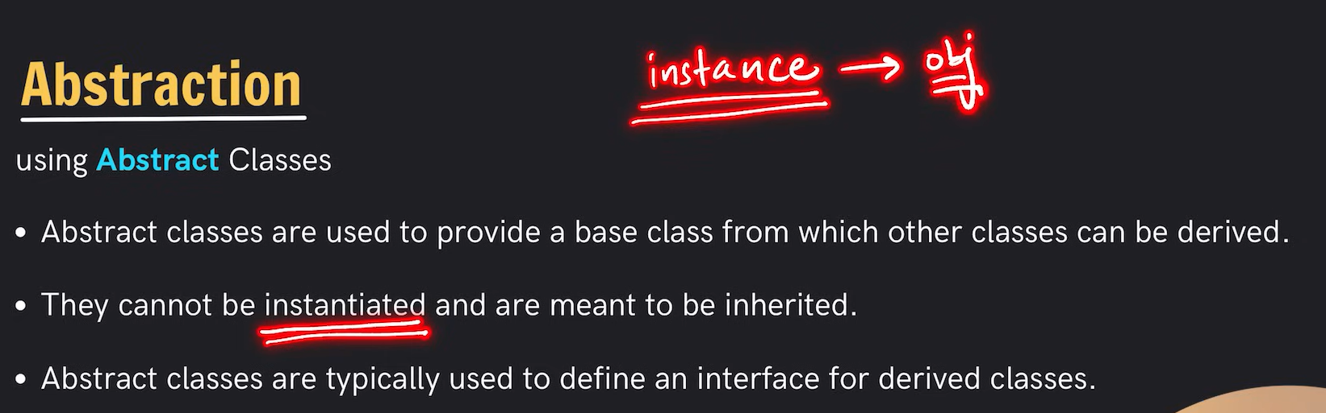**Abstraction in C++ is a fundamental concept of object-oriented programming (OOP) that focuses on hiding implementation details while exposing only essential features and functionality. It simplifies complex systems by modeling classes based on relevant data and behaviors, ignoring the underlying complexity.**

**Key Features of Abstraction:**

1. **Encapsulation: Combines data and functions that operate on the data into a single unit, often a class.**
2. **Hiding Implementation: Users interact with the object through its interface (public methods) without knowing the internal workings.**
3. **Focus on What, Not How: Defines what an object does rather than how it achieves it.**

**How to Achieve Abstraction in C++:**

**Abstraction can be achieved in C++ using:**

1. **Abstract Classes (with pure virtual functions).**
2. **Interfaces.**

**1. Abstract Classes:**

**An abstract class in C++ is a class that contains at least one pure virtual function. It cannot be instantiated directly and serves as a blueprint for derived classes.**

**Syntax:**

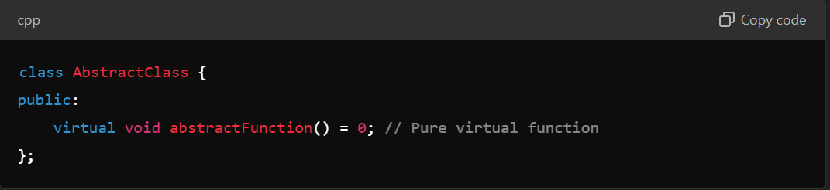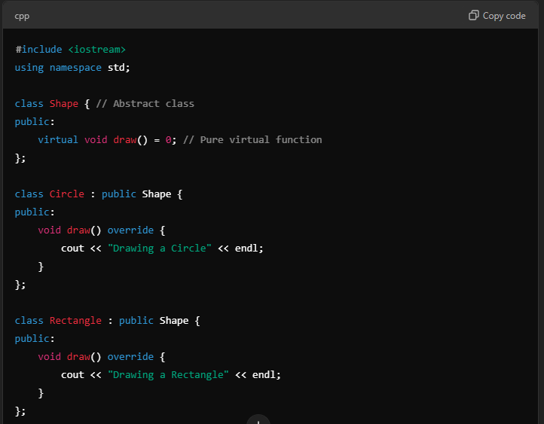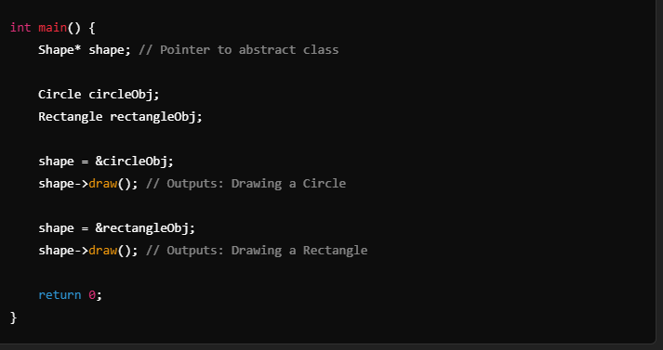**2. Interfaces:**

**C++ does not have a separate interface keyword like some languages (e.g., Java). Instead, you can achieve interfaces using abstract classes with all methods as pure virtual functions.**

**Example:**

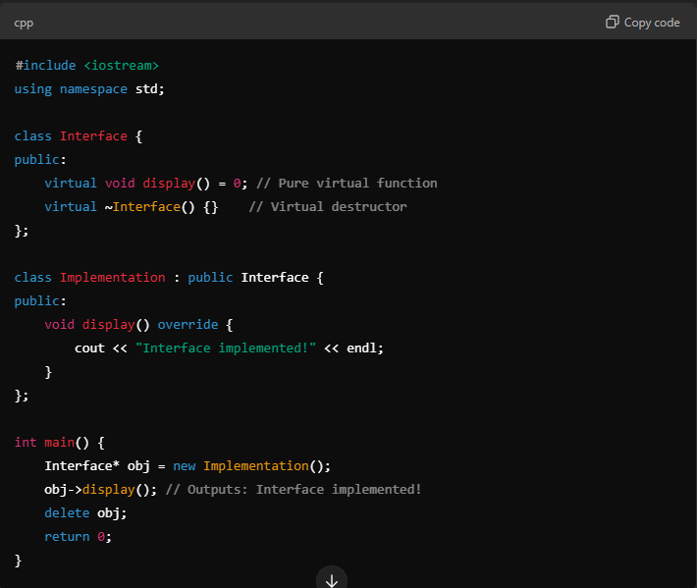**Real-World Analogy of Abstraction:**

**Think of a car:**

* **Interface (Abstraction): The car has a steering wheel, brake, accelerator, and gear shift. You use these controls to drive the car.**
* **Implementation (Hidden): The internal mechanism (engine, transmission, electronics) is hidden from the user.**

**Similarly, in software:**

* **The interface defines how objects interact.**
* **The implementation details are hidden within the object.**

**Advantages of Abstraction:**

1. **Simplified Interface: Provides a clear and simplified interface for users.**
2. **Reduces Complexity: Hides unnecessary details, making code easier to understand and maintain.**
3. **Promotes Reusability: Abstract classes and interfaces can be reused across different parts of a program or even other projects.**
4. **Improves Security: Hides sensitive data and implementation details, exposing only what is necessary.**

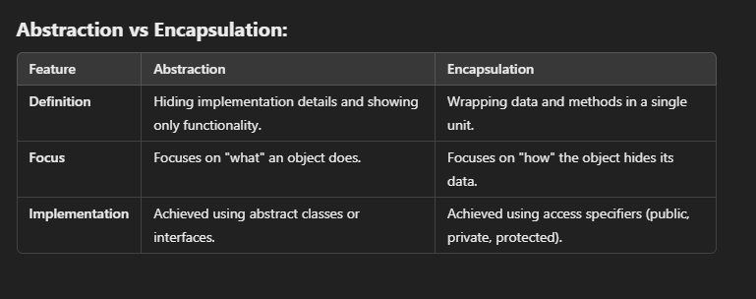**Abstraction helps in building modular and extensible systems by separating the interface from the implementation and focusing on delivering high-level functionality.**

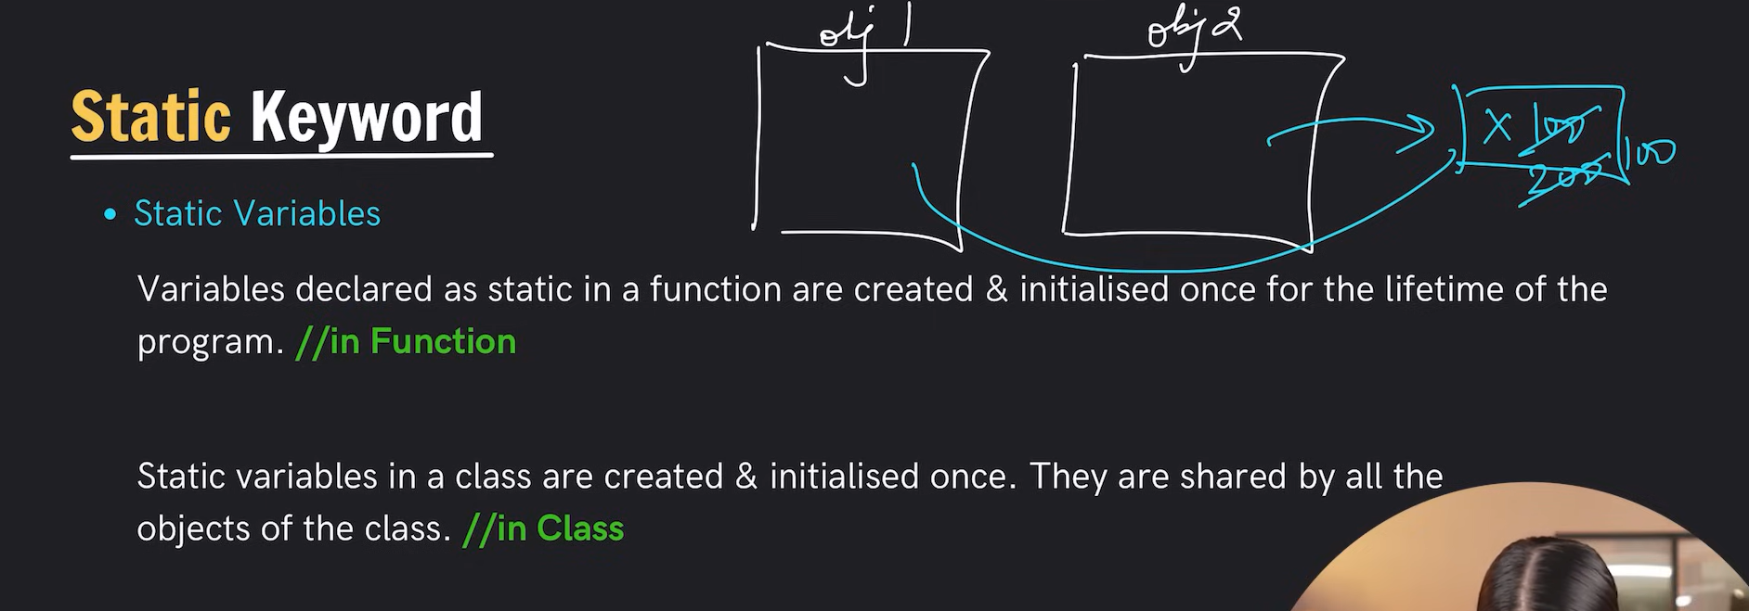

**In C++, a pair is a utility provided by the Standard Template Library (STL) to store two values as a single unit. It is defined in the <utility> header and can hold two values of possibly different types. The values are referred to as first and second.**

**Syntax:**

**#include <utility>**

**std::pair<Type1, Type2> pairName;**

**Key Features:**

1. **Holds Two Values:**
   * **The two values are accessed as pairName.first and pairName.second.**
2. **Can Store Different Types:**
   * **The two elements can be of the same or different types.**
3. **Simple Initialization:**
   * **Can be initialized directly or using the std::make_pair function.**
4. **Comparison Operators:**
   * **Supports relational operators (==, !=, <, >, etc.), which compare the first elements and then the second if needed.**

**Example:**

**#include <iostream>**

**#include <utility>**

**int main() {**

**// Creating a pair**

**std::pair<int, std::string> myPair(1, "Apple");**

**// Accessing elements**

**std::cout << "First: " << myPair.first << ", Second: " << myPair.second << std::endl;**

**// Using make_pair**

**std::pair<int, double> anotherPair = std::make_pair(5, 3.14);**

**std::cout << "First: " << anotherPair.first << ", Second: " << anotherPair.second << std::endl;**

**return 0;**

**}**

**Output:**

**First: 1, Second: Apple**

**First: 5, Second: 3.14**

**Use Cases:**

* **Returning multiple values from a function.**
* **Storing key-value pairs in containers like std::map.**

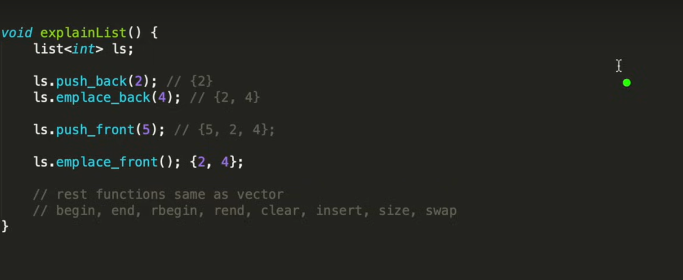

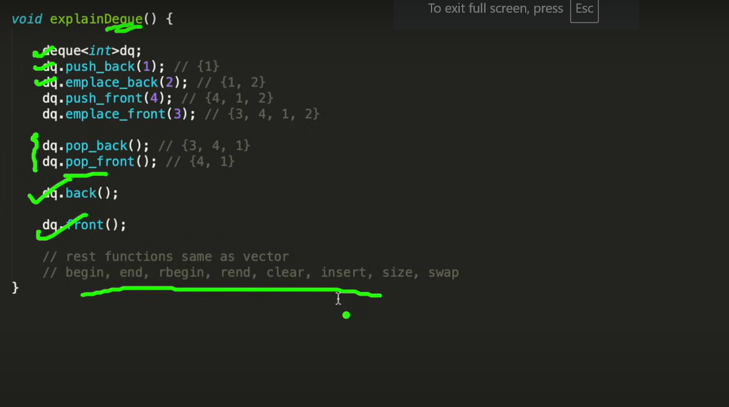

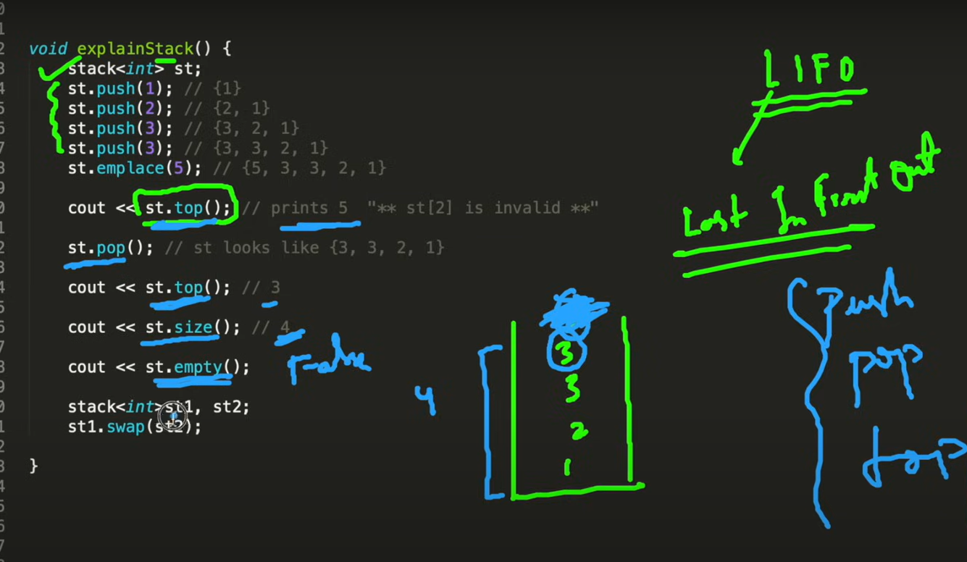

**Set**

**Key Characteristics of std::set:**

1. **Unique Elements:**
   * **A std::set automatically ensures all elements are unique.**
   * **If you try to insert a duplicate element, the insertion is ignored.**
2. **Ordered Elements:**
   * **The elements in a std::set are always stored in sorted order, according to the comparison function (by default, it uses < for ascending order).**
3. **Underlying Implementation:**
   * **Internally implemented as a balanced binary search tree, providing logarithmic time complexity for operations like insertion, deletion, and lookup.**
4. **Iterator Support:**
   * **Provides bidirectional iterators to traverse the elements in sorted order.**

**Syntax:**

**#include <set>**

**Common Member Functions:**

1. **Constructors:**
   * **Default, range-based, copy, and move constructors are supported.**
2. **std::set<int> mySet; // Default constructor**
3. **std::set<int> mySet2(mySet); // Copy constructor**
4. **Modifiers:**
   * **insert(value): Adds an element to the set.**
   * **erase(iterator/key): Removes an element by iterator or key.**
   * **clear(): Removes all elements.**
5. **Capacity:**
   * **size(): Returns the number of elements in the set.**
   * **empty(): Checks if the set is empty.**
6. **Lookup:**
   * **find(key): Searches for an element and returns an iterator.**
   * **count(key): Returns 1 if the element is present, otherwise 0.**
   * **lower_bound(key): Returns an iterator to the first element not less than the given key.**
   * **upper_bound(key): Returns an iterator to the first element greater than the given key.**
7. **Iterators:**
   * **Begin (begin()) and End (end()) iterators for traversal.**
8. **Comparison:**
   * **std::set supports relational operators like ==, !=, <, >, etc.**

**Example:**

**#include <iostream>**

**#include <set>**

**int main() {**

**std::set<int> mySet;**

**// Inserting elements**

**mySet.insert(10);**

**mySet.insert(20);**

**mySet.insert(10); // Duplicate, won't be added**

**mySet.insert(5);**

**// Printing the set**

**std::cout << "Set elements: ";**

**for (const auto &elem : mySet) {**

**std::cout << elem << " ";**

**}**

**// Searching for an element**

**if (mySet.find(10) != mySet.end()) {**

**std::cout << "\n10 is present in the set." << std::endl;**

**}**

**// Erasing an element**

**mySet.erase(10);**

**// Printing the set after erasure**

**std::cout << "Set elements after erasing 10: ";**

**for (const auto &elem : mySet) {**

**std::cout << elem << " ";**

**}**

**return 0;**

**}**

**Output:**

**Set elements: 5 10 20**

**10 is present in the set.**

**Set elements after erasing 10: 5 20**

**Variants of std::set:**

1. **std::multiset:** 
   * **Allows duplicate elements but maintains sorted order.**
2. **std::unordered_set:** 
   * **Stores unique elements but does not maintain any order (hash table-based).**

**Use Cases:**

* **Efficient searching and quick elimination of duplicates.**
* **Maintaining a collection of elements in sorted order.**

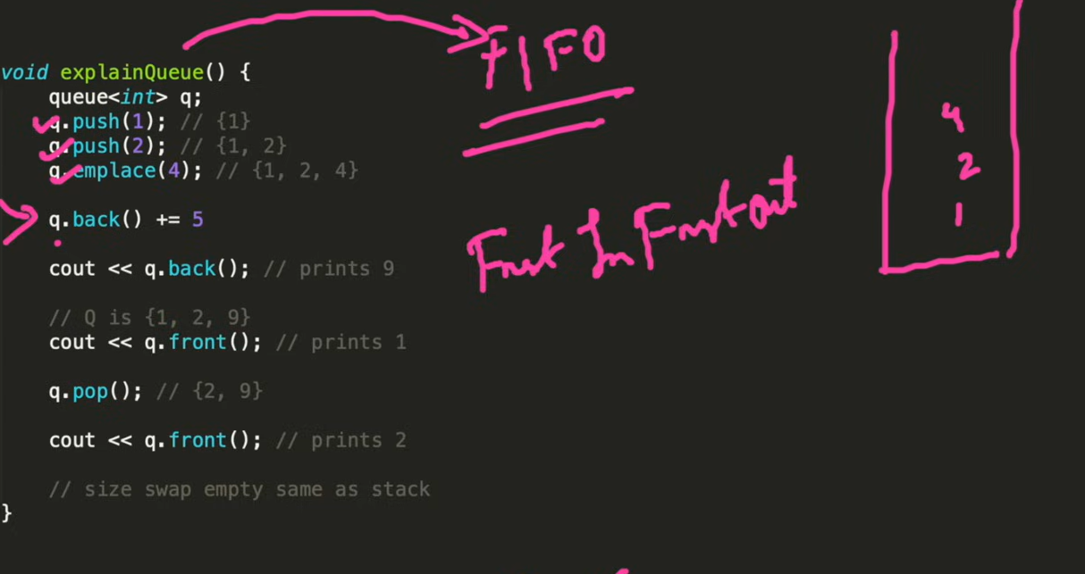

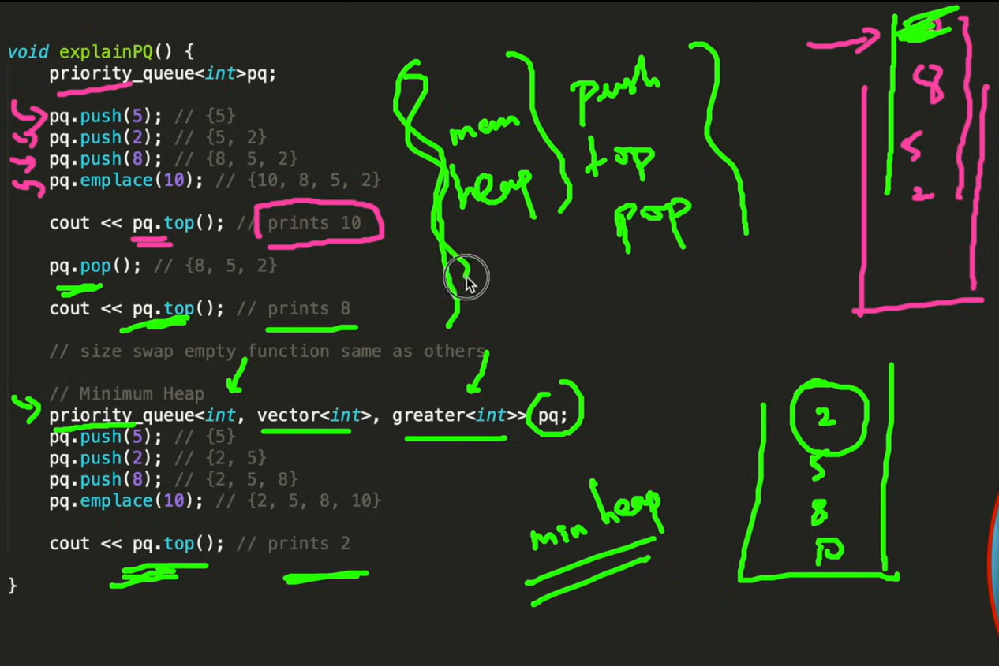

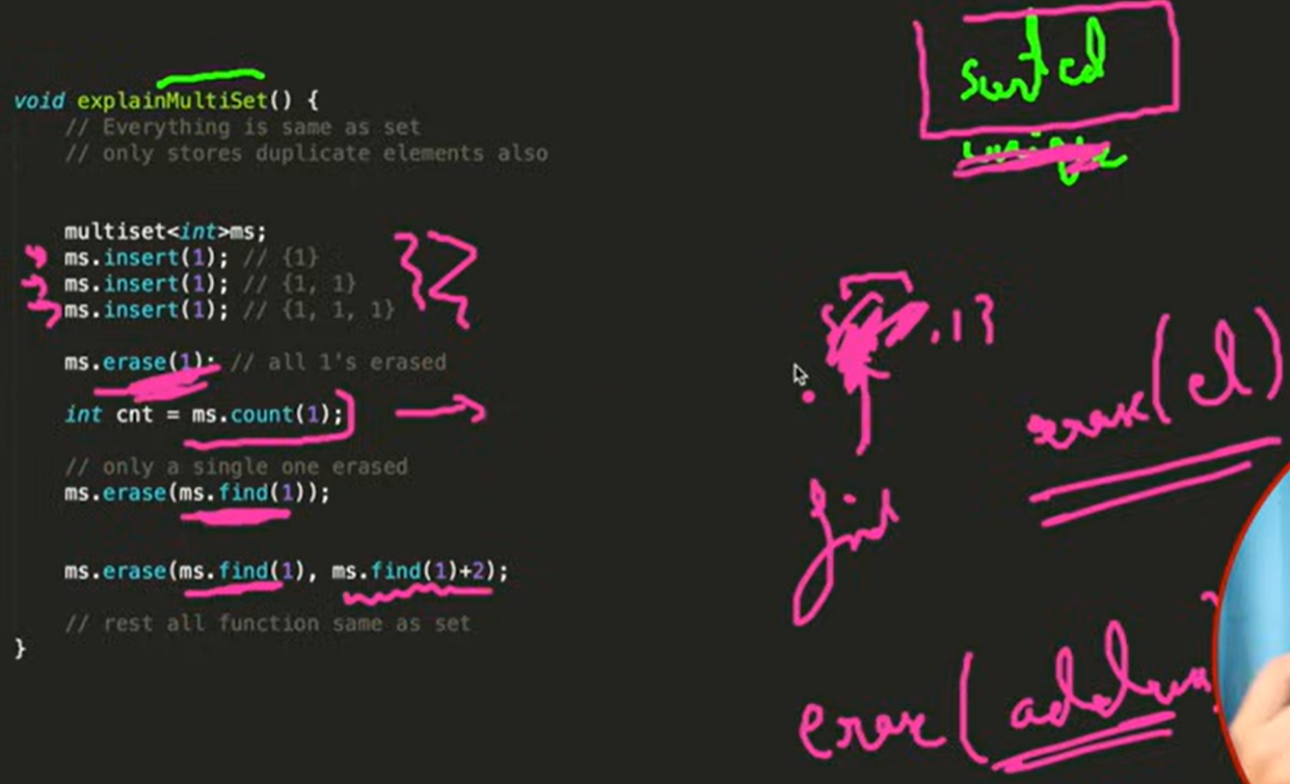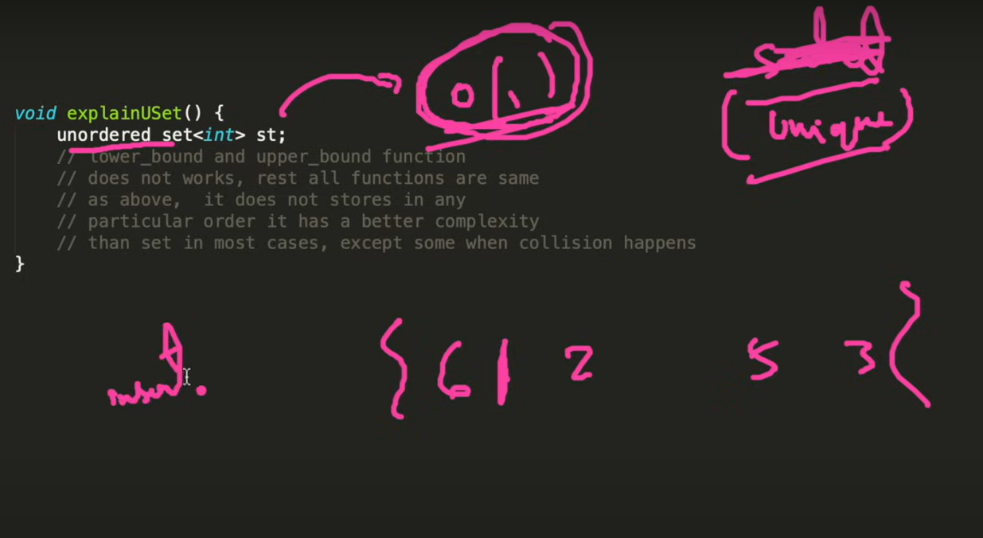

**In C++, a map is a container provided by the Standard Template Library (STL) that stores elements as key-value pairs in a sorted order. It is implemented as a balanced binary search tree (typically a Red-Black Tree) and ensures unique keys.**

**Key Characteristics of std::map:**

1. **Key-Value Pairs:**
   * **Each element in a std::map is stored as a pair: {key, value}.**
   * **The key is used for ordering and must be unique.**
   * **The value is associated with the key and can be accessed or modified.**
2. **Ordered Elements:**
   * **The elements in a std::map are automatically sorted by the key using the comparison function (default is < for ascending order).**
3. **Unique Keys:**
   * **A std::map ensures that there are no duplicate keys.**
   * **If you try to insert a key that already exists, the value associated with the key will not change unless explicitly updated.**
4. **Underlying Implementation:**
   * **Internally implemented as a balanced binary search tree, providing logarithmic time complexity for operations like insertion, deletion, and lookup.**
5. **Iterator Support:**
   * **Provides bidirectional iterators to traverse elements in sorted order of keys.**

**Syntax:**

**#include <map>**

**Common Member Functions:**

1. **Constructors:**
   * **Default, range-based, copy, and move constructors are supported.**
2. **std::map<int, std::string> myMap; // Default constructor**
3. **std::map<int, std::string> myMap2(myMap); // Copy constructor**
4. **Modifiers:**
   * **insert({key, value}): Adds a key-value pair.**
   * **erase(iterator/key): Removes an element by iterator or key.**
   * **clear(): Removes all elements.**
   * **operator[key]: Adds or modifies an element using the key.**
5. **Capacity:**
   * **size(): Returns the number of elements in the map.**
   * **empty(): Checks if the map is empty.**
6. **Lookup:**
   * **find(key): Searches for a key and returns an iterator to it.**
   * **count(key): Returns 1 if the key is present, otherwise 0.**
   * **lower_bound(key): Returns an iterator to the first key not less than the given key.**
   * **upper_bound(key): Returns an iterator to the first key greater than the given key.**
7. **Iterators:**
   * **Begin (begin()) and End (end()) iterators for traversal.**
8. **Comparison:**
   * **Supports relational operators like ==, !=, <, >, etc.**

**Example:**

**#include <iostream>**

**#include <map>**

**int main() {**

**std::map<int, std::string> myMap;**

**// Inserting elements**

**myMap.insert({1, "Apple"});**

**myMap.insert({3, "Banana"});**

**myMap[2] = "Cherry"; // Using operator[] to insert**

**myMap[3] = "Berry"; // Updates value for key 3**

**// Printing the map**

**std::cout << "Map elements:\n";**

**for (const auto &pair : myMap) {**

**std::cout << pair.first << ": " << pair.second << std::endl;**

**}**

**// Searching for a key**

**int key = 2;**

**if (myMap.find(key) != myMap.end()) {**

**std::cout << "\nKey " << key << " found with value: " << myMap[key] << std::endl;**

**}**

**// Erasing an element**

**myMap.erase(3);**

**// Printing the map after erasure**

**std::cout << "\nMap elements after erasing key 3:\n";**

**for (const auto &pair : myMap) {**

**std::cout << pair.first << ": " << pair.second << std::endl;**

**}**

**return 0;**

**}**

**Output:**

**Map elements:**

**1: Apple**

**2: Cherry**

**3: Berry**

**Key 2 found with value: Cherry**

**Map elements after erasing key 3:**

**1: Apple**

**2: Cherry**

**Variants of std::map:**

1. **std::multimap:** 
   * **Allows duplicate keys but maintains sorted order.**
2. **std::unordered_map:** 
   * **Stores key-value pairs without any order (hash table-based).**
3. **std::unordered_multimap:** 
   * **Allows duplicate keys and does not maintain order (hash table-based).**

**Key Differences from std::unordered_map:**

* **std::map maintains sorted order (logarithmic complexity).**
* **std::unordered_map does not maintain order but offers average constant-time complexity.**

**Use Cases:**

* **Associative storage where fast lookup and unique keys are required.**
* **Scenarios where elements need to be sorted based on keys.**